**Program 4**

**Aim**

To write a Python program to solve **Cryptarithmetic puzzles** by assigning digits to letters such that the given arithmetic equation is satisfied.

**Algorithm**

1. Take the words involved in the puzzle (e.g., "SEND + MORE = MONEY").
2. Extract all **unique letters**.
3. Generate all **permutations of digits** (0–9) for these letters.
4. Substitute digits into the words.
5. Check if the arithmetic equation holds.
6. Print the valid solution(s)

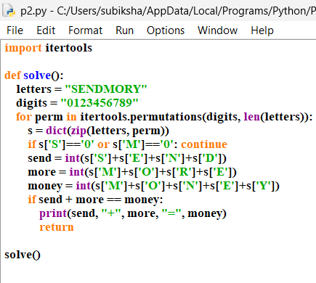

Output :

